**Client Entity**

1. **Insert new clients (insert):**

* **The Input :**

INSERT INTO Client

VALUES

('10', 'Ryann', 'Sullivann', DATE '1981-10-11', '33733732', '122 Main St., Crowley, LA 76036'),

('20', 'Stive', 'Bolt', DATE '1989-10-10', '33744332', '121 Main St., Crowley, NM 76036'),

('30', 'John', 'Brown', DATE '1983-10-7', '33733355', '4723 Green St., Houston, TX 77044'),

('40', 'Adam', 'Downson', DATE '1986-10-1', '33733365', '123 Valley St., Dallas, TX 79054'),

('50', 'Oscar', 'Templeton', DATE '1984-5-22', '33733326', '123 Ginosa St., Austin, TX 70022');

* **The Expected Output :**

|  |  |  |  |  |  |
| --- | --- | --- | --- | --- | --- |
| **clientID** | **fName** | **lName** | **DOB** | **phoneNo** | **address** |
| **10** | Ryann | Sullivann | 1981-10-11 | 33733732 | 122 Main St., Crowley, LA 76036 |
| **20** | Stive | Bolt | 1989-10-10 | 33744332 | 121 Main St., Crowley, NM 76036 |
| **30** | John | Brown | 1983-10-7 | 33733355 | 4723 Green St., Houston, TX 77044 |
| **40** | Adam | Downson | 1986-10-1 | 33733365 | 123 Valley St., Dallas, TX 79054 |
| **50** | Oscar | Templeton | 1984-5-22 | 33733326 | 123 Ginosa St., Austin, TX 70022 |

* **The Actual Output :**

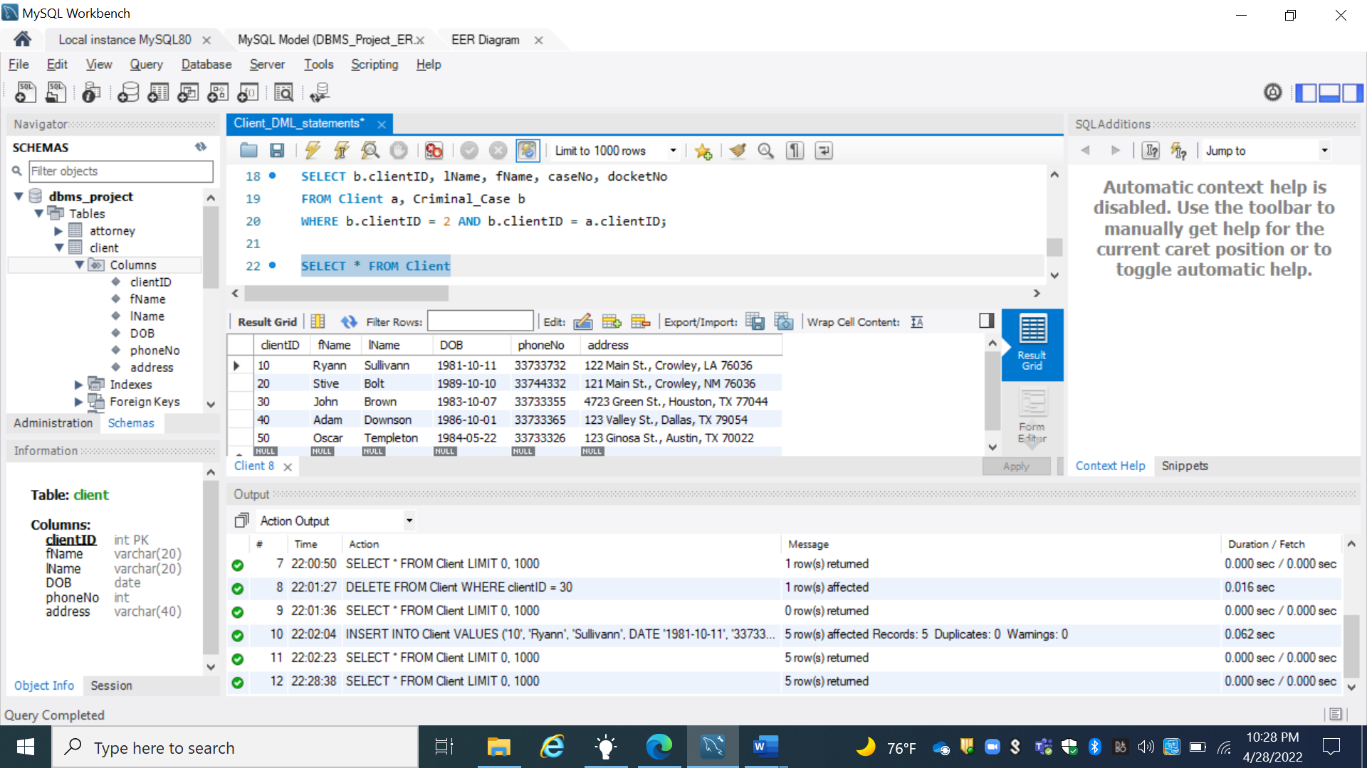

1. **How many clients does the 15th JDC PDO represent? (aggregate):**

* **The Input :**

SELECT COUNT (clientID) AS clientCount

FROM Client;

* **The Expected Output :**

|  |
| --- |
| **clientCount** |
| **5** |

**The Actual Output :**

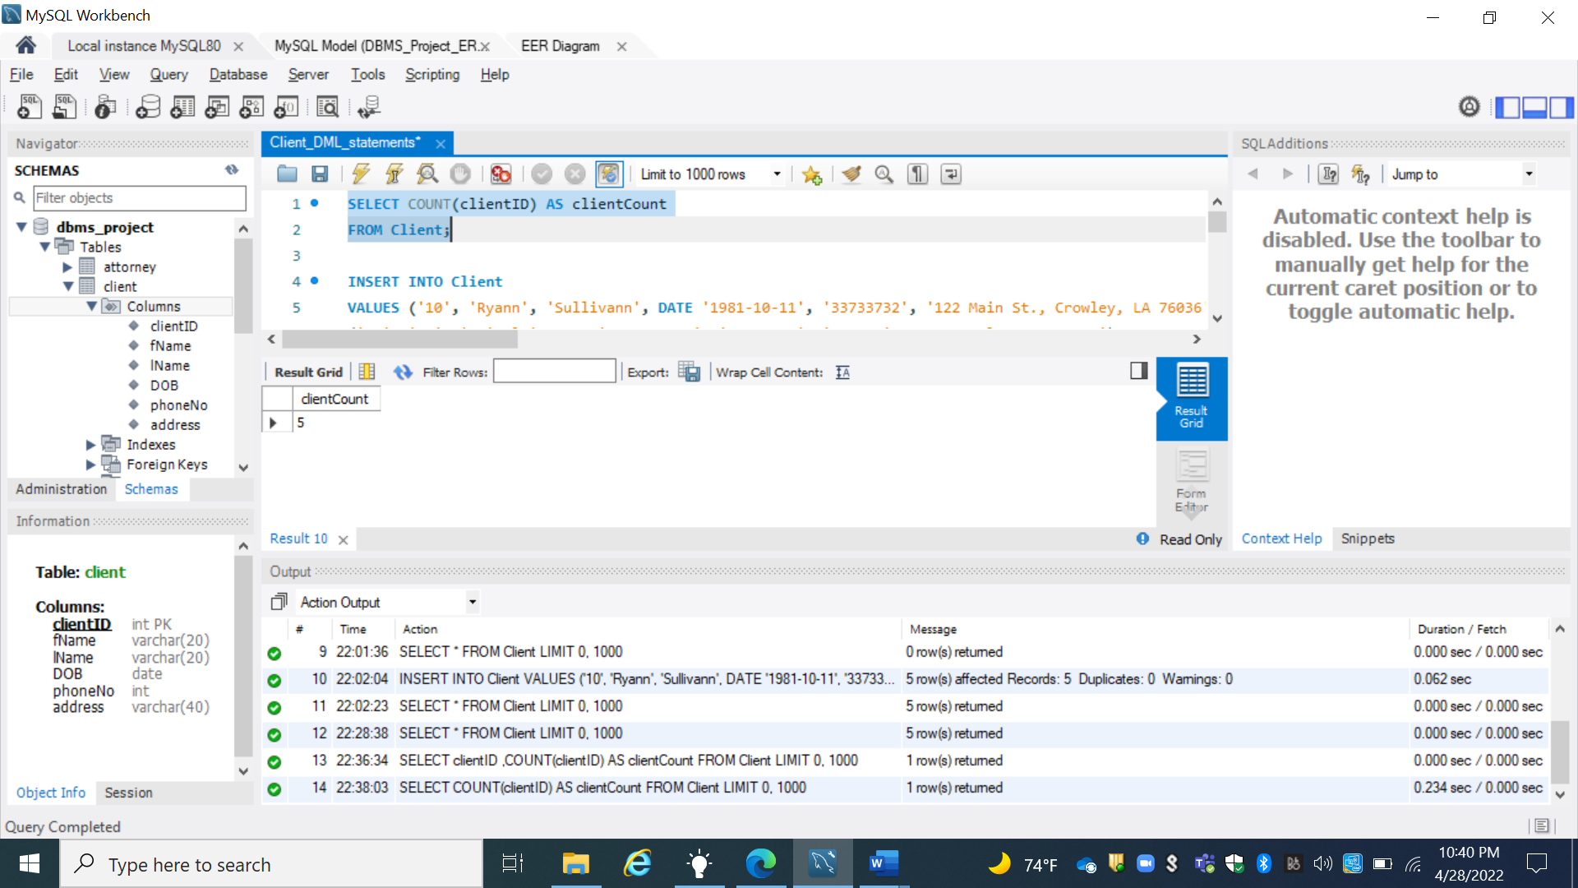

1. **Delete client with clientID 1(delete):**

* **The Input :**

DELETE FROM Client

WHERE clientID = 40;

* **The Expected Output :**

|  |  |  |  |  |  |
| --- | --- | --- | --- | --- | --- |
| **clientID** | **fName** | **lName** | **DOB** | **phoneNo** | **address** |
| **10** | Ryann | Sullivann | 1981-10-11 | 33733732 | 122 Main St., Crowley, LA 76036 |
| **20** | Stive | Bolt | 1989-10-10 | 33744332 | 121 Main St., Crowley, NM 76036 |
| **30** | John | Brown | 1983-10-7 | 33733355 | 4723 Green St., Houston, TX 77044 |
| **50** | Oscar | Templeton | 1984-5-22 | 33733326 | 123 Ginosa St., Austin, TX 70022 |

* **The Actual Output :**

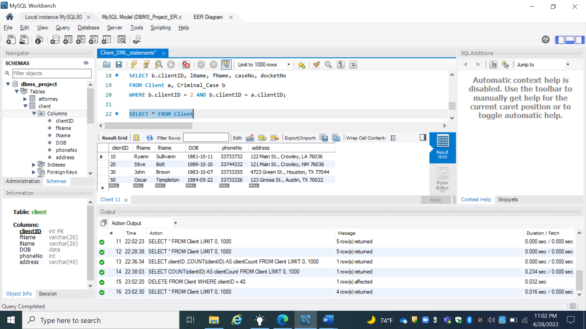

1. **Update phoneNo for client with clientID 2(update)**

* **The Input :**

UPDATE Client

SET phoneNo = 33788890

WHERE clientID = 20;

* **The expected Output :**

|  |  |  |  |  |  |
| --- | --- | --- | --- | --- | --- |
| **clientID** | **fName** | **lName** | **DOB** | **phoneNo** | **address** |
| **10** | Ryann | Sullivann | 1981-10-11 | 33733732 | 122 Main St., Crowley, LA 76036 |
| **20** | Stive | Bolt | 1989-10-10 | 33788890 | 121 Main St., Crowley, NM 76036 |
| **30** | John | Brown | 1983-10-7 | 33733355 | 4723 Green St., Houston, TX 77044 |
| **50** | Oscar | Templeton | 1984-5-22 | 33733326 | 123 Ginosa St., Austin, TX 70022 |

* **The Actual Output :**

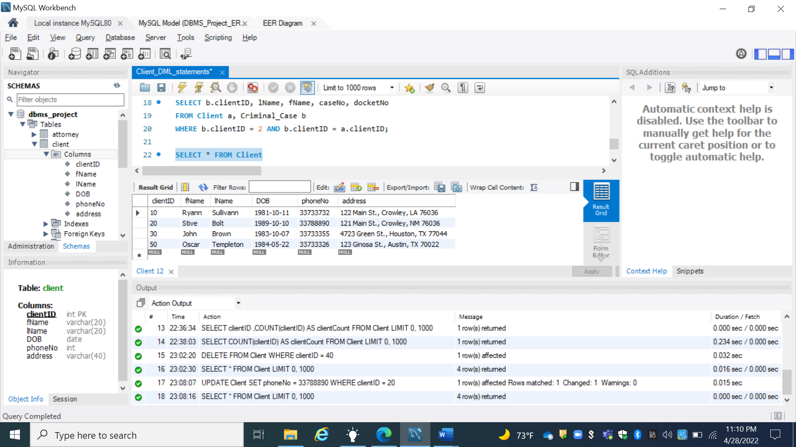

1. **List ClientID, lName, fName, caseNo and docketNo for all cases belonging to client with clientID 2 (join Client/Criminal case)**

* **The Input :**

SELECT b.clientID, lName, fName, caseNo, docketNo

FROM Client a, Criminal_Case b

WHERE b.clientID = 20 AND b.clientID = a.clientID;

* **The Expected Output :**

|  |  |  |  |  |
| --- | --- | --- | --- | --- |
| clientID | lName | fName | caseNo | docketNo |
| 20 | Bolt | Stive | 20 | 23345 |

* **The Actual Output :**

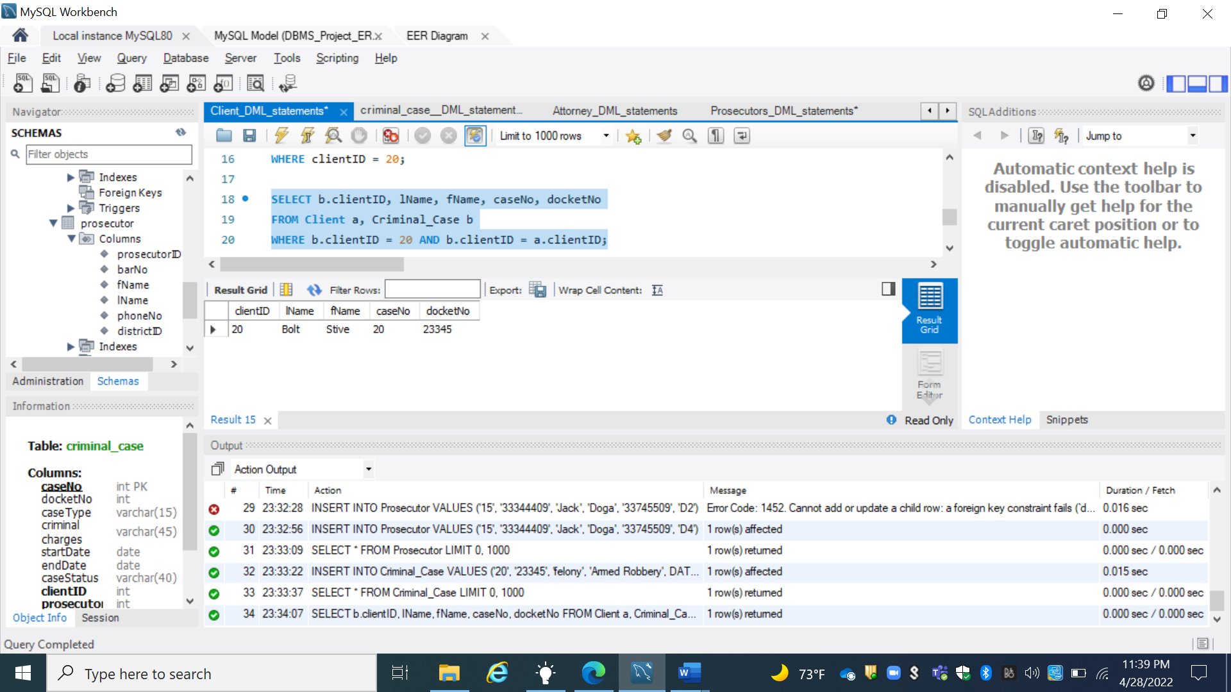

**Prosecutor Entity**

1. **Insert new prosecutor (insert)**

* **The Input :**

INSERT INTO Prosecutor

VALUES

('15', '33344409', 'Jack', 'Doga', '33745509', 'D4'),

('16', '33344410', 'Danny', 'Doglas', '33745511', 'D5'),

('17', '33344411', 'Robert', 'Albert', '33745573', 'D6'),

('18', '33344412', 'Jason', 'Thomas', '33745577', 'D6'),

('19', '33344413', 'Peter', 'Rodrigo', '33745500', 'D8');

* **The Expected Output**

|  |  |  |  |  |  |
| --- | --- | --- | --- | --- | --- |
| **prosecutorID** | **barNo** | **fName** | **lName** | **phoneNo** | **districtID** |
| 15 | 33344409 | Jack | Doga | 33745509 | D4 |
| **16** | 33344410 | Danny | Doglas | 33745511 | D5 |
| **17** | 33344411 | Robert | Albert | 33745573 | D6 |
| **18** | 33344412 | Jason | Thomas | 33745577 | D7 |
| **19** | 33344413 | Peter | Rodrigo | 33745500 | D8 |

* **The Actual Output**

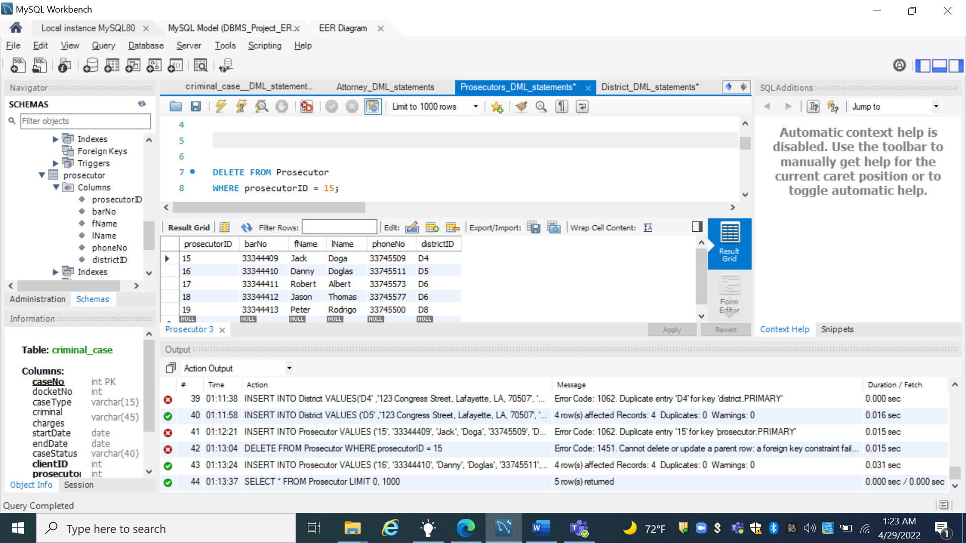

1. **How many prosecutors work in District with districtID D2 ? (aggregate)**

* **The Input :**

SELECT COUNT(ProsecutorID) AS prosecutorCount

FROM Prosecutor

WHERE districtID = 'D4';

* **The Expected Output :**

|  |
| --- |
| **proscutorCount** |
| **1** |

* **The Actual Output :**

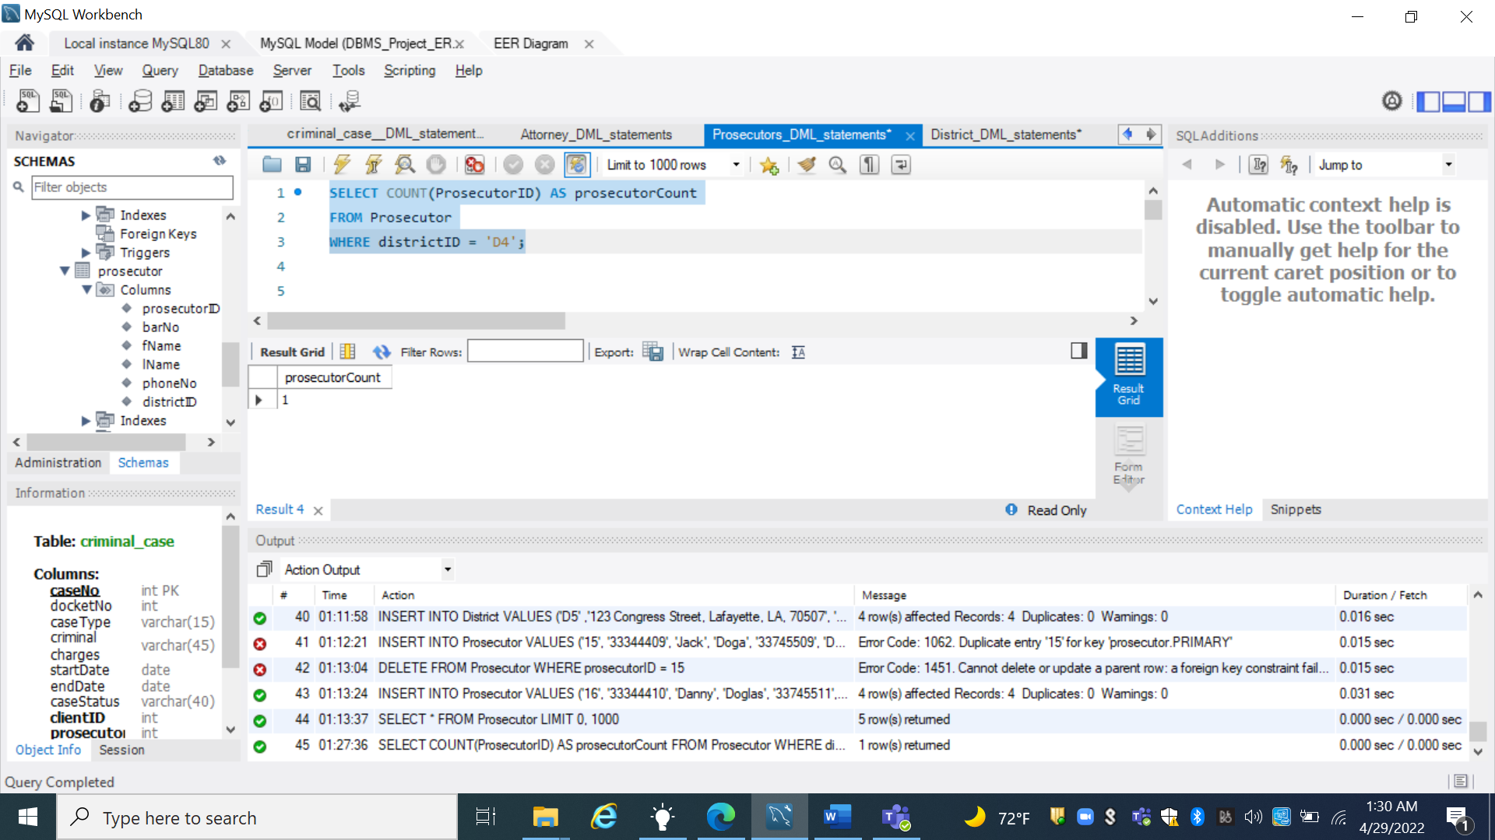

1. **Delete prosecutor with prosecutorID 1 (delete)**

* **The Input :**

DELETE FROM Prosecutor

WHERE prosecutorID = 16;

* **The Expected Output :**

|  |  |  |  |  |  |
| --- | --- | --- | --- | --- | --- |
| **prosecutorID** | **barNo** | **fName** | **lName** | **phoneNo** | **districtID** |
| 15 | 33344409 | Jack | Doga | 33745509 | D4 |
| **17** | 33344411 | Robert | Albert | 33745573 | D6 |
| **18** | 33344412 | Jason | Thomas | 33745577 | D7 |
| **19** | 33344413 | Peter | Rodrigo | 33745500 | D8 |

* **The Actual Output :**

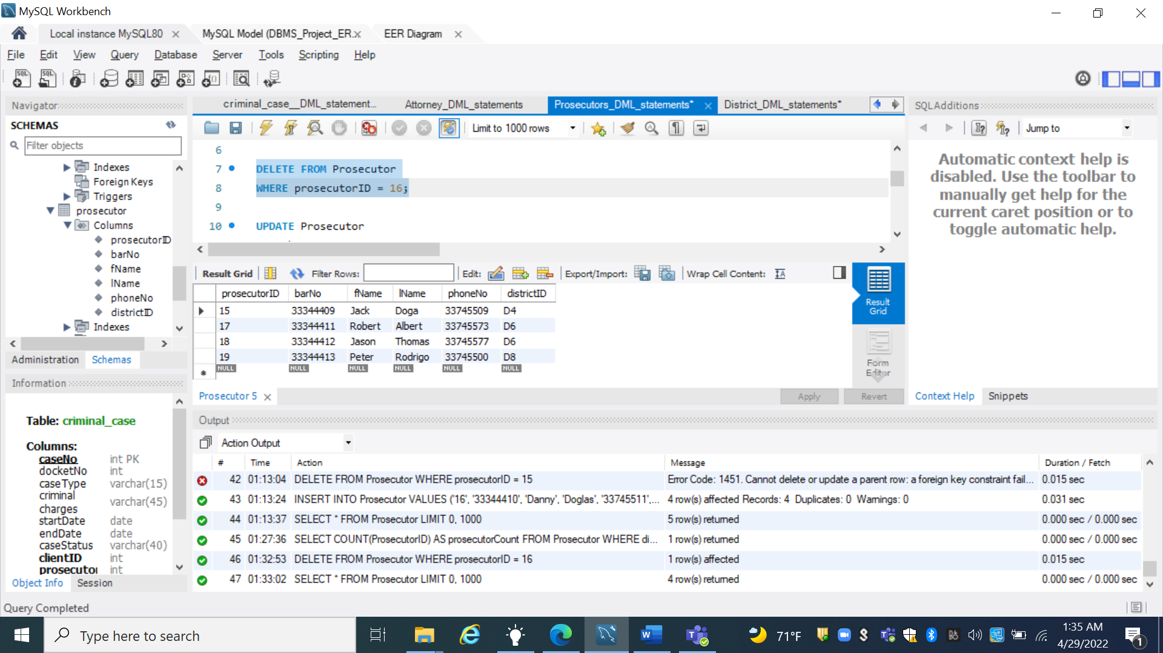

1. **Update phoneNo for prosecutor with prosecutor ID 2(update)**

* **The Input :**

UPDATE Prosecutor

SET phoneNo = 33744455

WHERE prosecutorID = 17;

* **The Expected Output :**

|  |  |  |  |  |  |
| --- | --- | --- | --- | --- | --- |
| **prosecutorID** | **barNo** | **fName** | **lName** | **phoneNo** | **districtID** |
| 15 | 33344409 | Jack | Doga | 33745509 | D4 |
| **17** | 33344411 | Robert | Albert | 33744455 | D6 |
| **18** | 33344412 | Jason | Thomas | 33745577 | D7 |
| **19** | 33344413 | Peter | Rodrigo | 33745500 | D8 |

* **The Actual Output :**

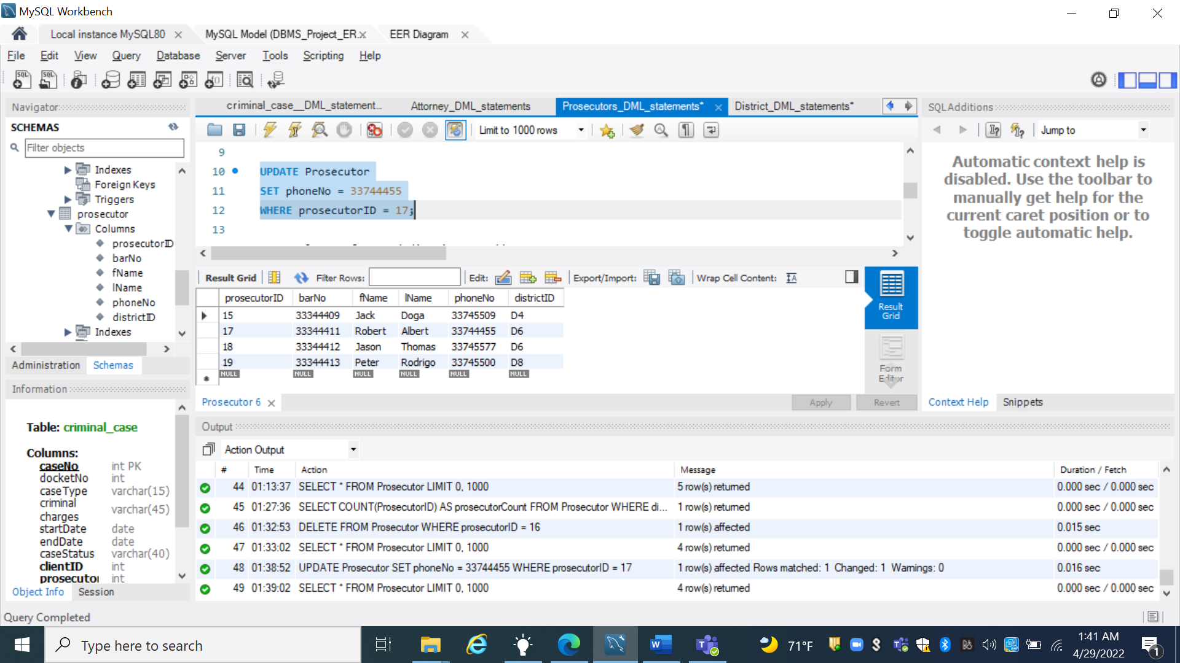

1. **List lName, fName, districtID, and address for all Prosecutors, sorted by districtID (join)**

* **The Input :**

SELECT lName, fName, d.districtID, address

FROM District d, Prosecutor p

WHERE d.districtID = p.districtID;

* **The Expected Output :**

|  |  |  |  |
| --- | --- | --- | --- |
| lName | fName | districtID | address |
| Doga | Jack | D4 | 123 Congress Street, Lafayette, LA, 70507 |
| Albert | Robert | D6 | 222 Main Street, Lafayette, LA, 70563 |
| Thomas | Jason | D7 | 244 Felona St, Lafayette, LA, 70500 |
| Rodrigo | Peter | D8 | 111 Rosa STt, Lafayette, LA, 70511 |

* **The Actual Output :**

